

Volunteers’ Management System
User Manual for Managers

By:
Apollo Group

Table of Contents
Content Page #

Table of Contents 2
1 Introduction 3
2 About VMS 4
3 How to 5
3.1 How to register and login 5
3.2 How to ceate and edit crisis 6
3.3 How to create and edit incident 7
3.4 How to create and edit requests to volunteers 8
3.5 How to search and send alert to volunteers 8
4 Troubleshooting 9
5 Installation guidelines 10
6 Glossary 11
7 Revision histroy 12

Introduction

This guideline will help VMS Managers to know about different functionalities of the system more quickly. So they can perform their operations in a more effective way. It explains what procedures you need follow to perform certain task.
It’s structured in such a way, so you find it easy to start operating this system. It first explains you how to define a crisis and then how to operate incidents within that in order to manage resources better during crisis time. Further, it also explains other options in VMS.

About VMS

Volunteer Management System is an IT system that enables help organizations to utilize or get benefits from regular citizens to help the people in case of any crisis. During crisis enables an effective communication and easy management of resources both as human or other resources and also facilitates the help organization to find additional workforce from general public whenever human potential is in full demand.

In order to collect requirements from volunteers that are needed in the crisis time and also using their helpful stuff VMS establishes a safe communication between volunteers and management center. The system will also help to gather helpful crisis information from volunteers. In the other side VMS assist manager to manage resources and transfer important information easily. VMS is to provide efficient ways for selecting and assigning volunteers and their helpful stuff to incidents inside a crisis according to their available information at that time.

How To

How to register and log in:
The manager needs be registered first to be able to log in the VMS.

Steps of manager registration:

- Go to login page of the website ‘http://licrp.dnsalias.net/apollo/login.aspx’
- Select user type as ‘Manager’ from log in page
- Click ‘Register’ button
- Fill the registration form.
- Click Register button
- You’ll be guided to login page again, in order to login.

The error messages will be displayed for some of the field values are correct. If the new users ‘user name’ field value is same as the existing user then the new user will be indicated with error message.

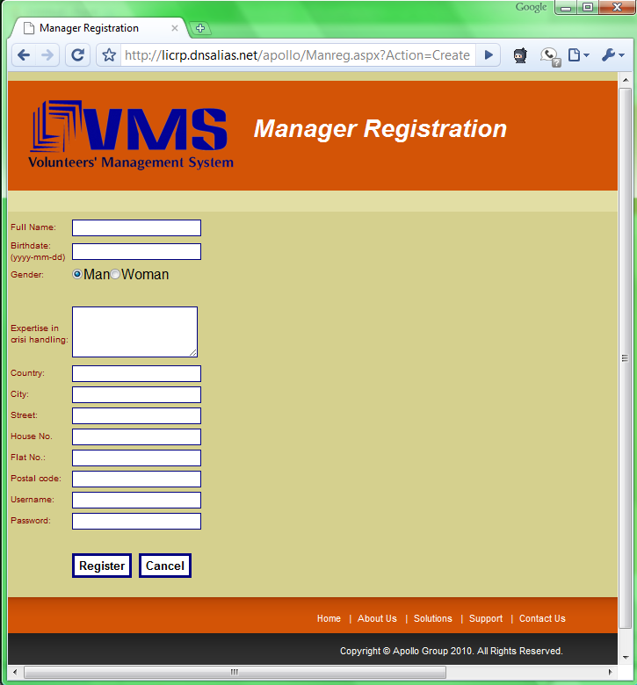
Figrure 3.1 (a)

Steps of manager Log in:
The registered manager can log in the VMS.

- Go to login page of the website ‘http://licrp.dnsalias.net/apollo/login.aspx’
- Enter valid username and password
- Select ‘Manager’ as user type and click ‘Login
- You will be guided to the main page in order to perform operations required

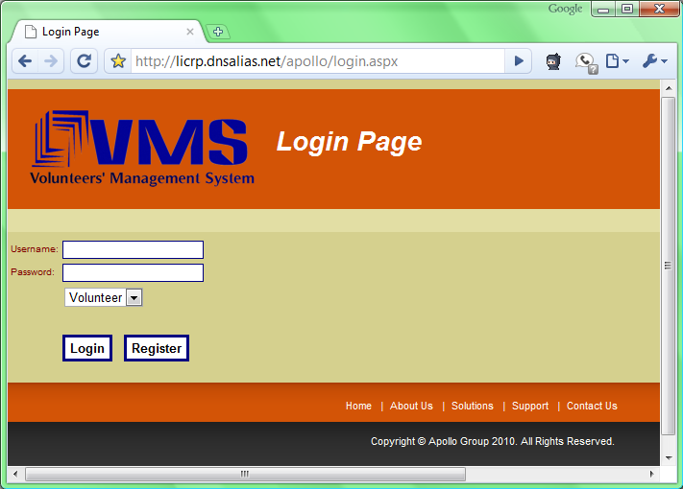
Figure 3.1 (b)

  - How to create a crisis
The manager needs to create a crisis to be able to manage and report all the actions can come up during the crisis

Steps of creating crisis:

After login in the application, you will be guided to the main page then you will see new Crisis Information Page containing a map.
- Enter a name for the crisis in ‘crisis name’ field
- Define the area on the map by selecting the area and clicking it
- Select type of the crisis from a list
- Enter details of crisis, in explanation field
- Click ‘save button’.
You will be guided to the Management main page to perform the rest of the operations.

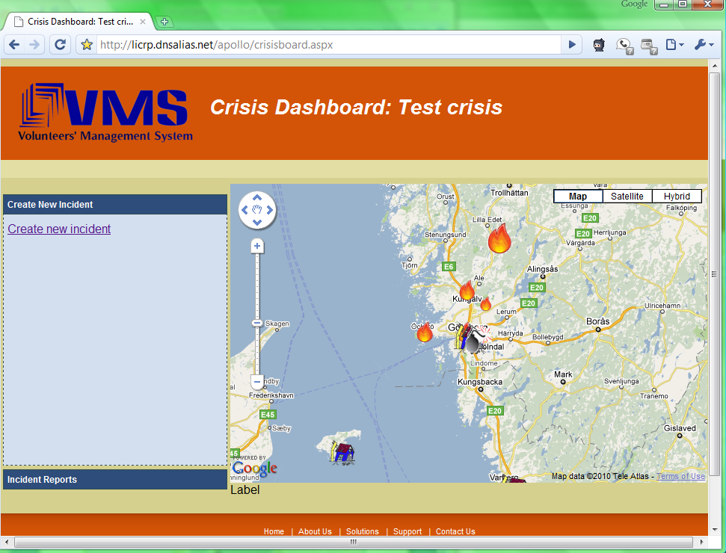
Figure 3.2

Steps of editing and closing crisis:

The crisis has been created, could be edited and closed by the manager
- Select an active crisis and then click on ‘edit crisis’
- The system will guide you to the page, where you can edit information for the crisis.
- Save the changes by click ‘Save’ button.
- For closing a crisis, Click ‘close’ button.

How to create incidents
More than one incident can be raised in a crisis and each incident will have individual need list and requirements, these will be handled by VMS by assisting the crisis manger in handling them according to the nature of incidents. To define the incident in the VMS following this steps

Steps of creating incident:
- Click ‘Create incident’ from crisis board.
- Fill:
Incident area on the map by name -> Incident type -> Severity -> Description about this incident-> Explanation->Needed items one-by-one-> Short address to find accurate place
- Click ‘Save’ button, to add incident in the system.

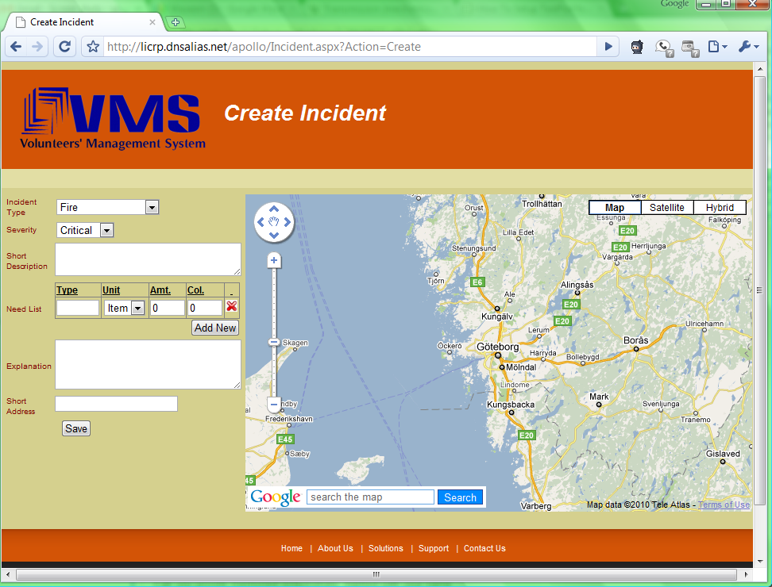
Figure 3.3

Steps of editing incident:

To editing incident there are two ways, you as a manager can select desired incident on the map and click on ‘Edit Incident’ link or select ‘List all incidents’ in the crisis board in order to find your desired incident so after select incident follow this steps:
- Make the required changes you want to do in incident
- Press ‘Save’ button

Steps of closing Incident:

In order to close an incident following steps:
- Select incident on Crisis board or on the map
- Select ‘Edit incident’ link
- Click ‘close incident’ button

How to create and edit requests
A manager can send a help request to volunteers based on the location and the type of crisis. By sending help request, the manger gets the response from volunteers.

Steps of creating request:

To create requests there are two ways, you as a manager can select desired incident on the map and click on ‘Resource Gathering’ link or select ‘List all incidents’ in the crisis board in order to find your desired incident and select ‘Resource Gathering’ button so after select incident follow these steps:

- Select incident by the explanation above
- Click ‘Resource Gathering ’ button
- Click ‘Add’ button
- Fill:
Request name -> Request Message
- Select ‘need items’ which the manager wants to request in this message
- Click ‘Save’ button
System automatically sends the request to volunteers who are in the incident location

Steps of editing request:
In order to edit request, follow the below steps:

- Select incident by explanation above
- Click ‘Resource Gathering ’ button
- Select ‘Edit request’ button of desired requests on the list
- Make the required changes you want to do in the request
- Click ‘Save’

How to search volunteer and send alert to them

Steps of searching volunteer:
- On the crisis management main page, you need to select area where you want to search volunteer(s)
- Then in search box, write the search text, and click ‘Search’ button
- It will show you the list of volunteers.

Steps of sending alert:
Alert messages will be sent to volunteers based on their location and also their association towards the crisis. In order to sending alert following steps:
- Select’ Send alert’ link on the crisis board
- Select volunteers
- Enter alert message
- Click ‘send’

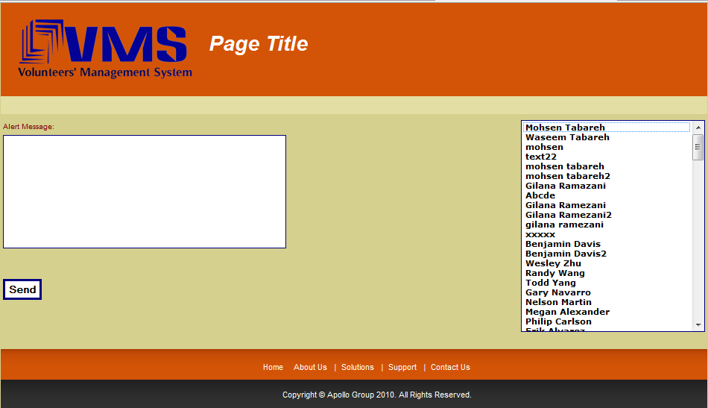

Troubleshooting
TBL

User Guidelines
TBL

Glossary

Manager: | Person who responsible for managing Volunteer management system, and is part of the help organization.
Volunteer: | The people who will use the VMS for helping other people on /before/after to the crisis, but not with the administrative responsibilities.
Crisis: | In VMS, manager defines crisis which is can have one or more incidents defined in it. (Refer: ‘incident’)
Incident: | Incident is any kind of unexpected and non-routine event that can cause trouble to the human beings normal day to day life.
Need List: | List of needed items, which are required in relief work for the incident
VMS: | Volunteer management system is also referred as VMS
Map: | In VMS, you can define location in the map area.
Mobile application: | This is an application which Volunteers use on their mobile phone. For all communication between help organization and volunteer, Volunteer uses this application
Web application: | Manager uses this web application, where all crisis related activities can be performed. And management of volunteers can be done.

- Revision History

Name | Date | Description | Version
Waseem Soomro | 25 Apr 10 | Created a User-Manual with initial outline | 0.1
Waseem Soomro | 03 May 10 | Revised Introduction and How To sections | 0.2
Waseem Soomro | 04 May 10 | Revised Glossary, How To sections | 2.0
Gilana Ramezani,  Mustafa Al-Zubaidi | 05 May 10 | Reviewed | 2.1
Waseem Soomro | 05 May 10 | Added About VMS part, added screenshots, and fixed defects | 2.1
Team | 05 May 10 | Shared to the peer group (Evolution) for review | 2.2
Waseem Soomro | 06 May 10 | Changes made after peer-review-comments | 3.0
Gilana Ramezani | 11 May 10 | Edit and Revise Introduction section, steps 3.3, 3.4 and 3.5. | 3.1
Mustafa Al-Zubaidi | 11 May 10 | Edit and Revise section 2 (about VMS), steps 3.1and 3.2. | 3.1
Mustafa Al-Zubaidi | 15 May 10 | Reviewed whole the document and fixed it. | 3.1

